MINISTRIES

INREACH (CHURCH FAMILY)
1. Building and Grounds
Chairperson or Primary Contact: Chris Crocker, Junior Warden

Phone Number: (518)703-9918

Email Address: acrocker53@gmail.com
Statement of Mission or Purpose: Maintain the building and grounds in good working order within budget constraints. Priorities are established on the basis of a beginning of the year inspection conducted by the Junior Warden. With the approval of the Vestry and with direction from the Junior Warden, some functions may be performed by contractors with direction from the Junior Warden.

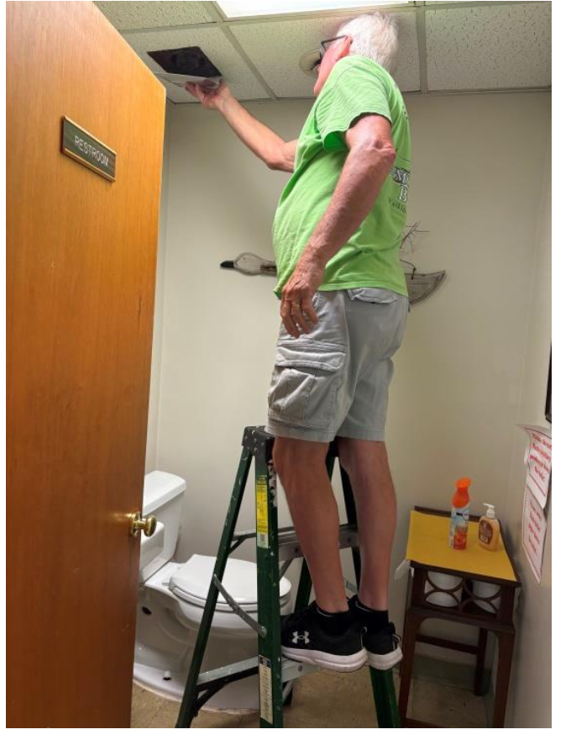

2. Children’s & Youth Ministries
Chairperson or Primary Contact: Pretlow Pacheco
Phone Number: 757-577-6920
Email Address: pretlow.pacheco@gmail.com
Statement of Mission or Purpose: Our purpose is to cooperate with God in forming Christians. We do this by instructing our church youth about the word of God, and the love of our savior Jesus Christ. In addition, we wish to help our young develop a sense of family, home, and Christian Community within and without our church walls so they may be better able to negotiate all they may encounter in their lives. We hope this will give them a foundation on which to build their own spiritual lives.

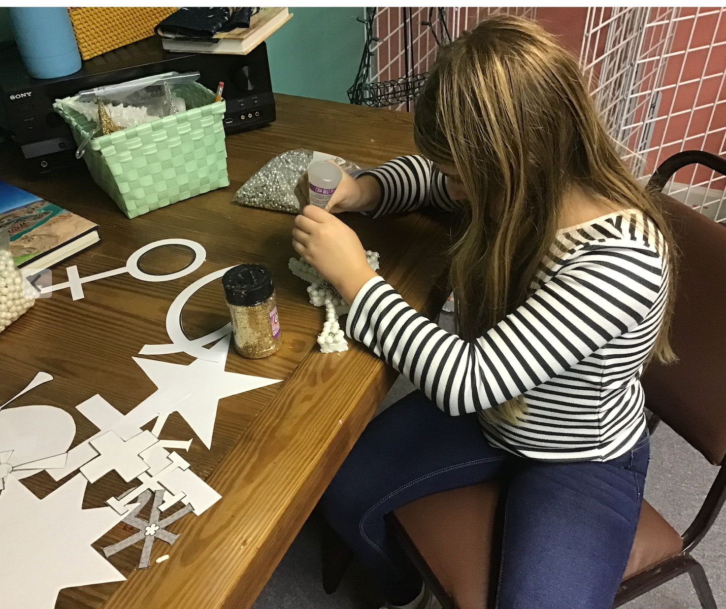

3.Classics Luncheons
Chairperson or Primary Contact: Joanne Willis
Phone Numbers: (757) 357-9710 & (757) 357-7483
Email Address: jowillis@charter.net
Statement of Mission or Purpose: To honor the lives and achievements of Christ Church Seniors.

4. Creation Care
Chairperson: Alison Crocker

Phone Numbers: 518-505-5966

Email Address: acrocker53@gmail.com
Statement of Mission or Purpose: One of the objectives of the national Episcopal church is to care for all of God’s creatures and the planet. Our goal is to cut down on waste within the church and eventually expand our programinto our community in order to protect the plants and animals of God’s creation.

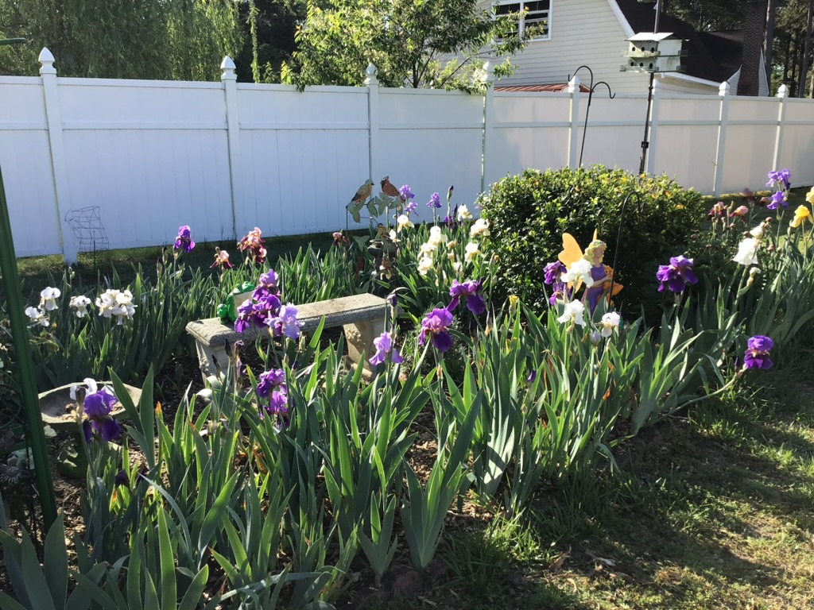

5. Cursillo
Chairperson or Primary Contact: Peter Lowry

Phone Numbers: (757) 630-8719
Email Address: plowry819@gmail.com
Statement of Mission or Purpose: Cursillo is a national program that seeks to enable the essential realities of the Christian to come to life in the uniqueness, originality and creativity of each person.

6. Hospitality
Chairperson or Primary Contact: Kim Leazer

Phone Number 757-810-4100

Email Address: kimberly.leazar@yahoo.com
Statement of Mission or Purpose: To foster fellowship within the church by providing a welcoming atmosphere for parishioners, guests and visitors alike.
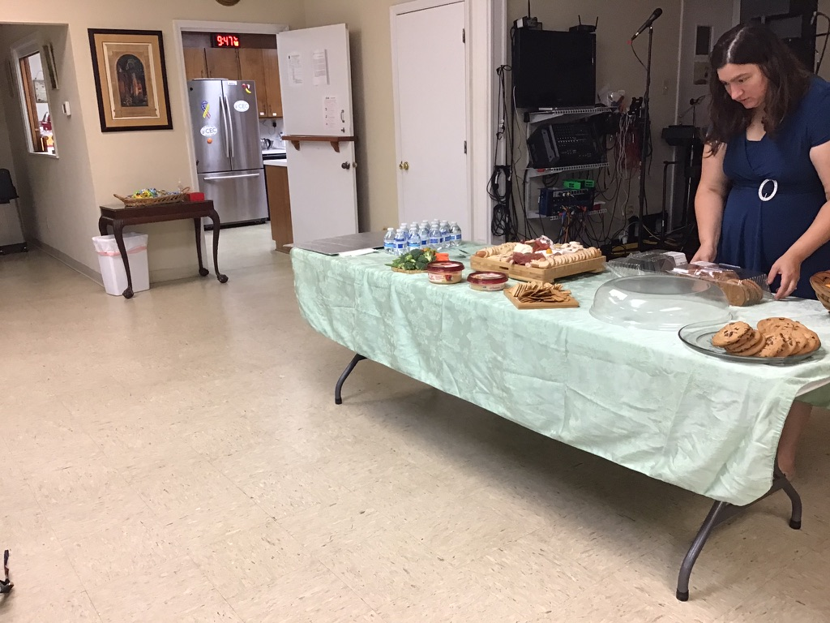

7. Newcomers
Chairperson or Primary Contact: Rosemarie White

Phone Number: (757) 357-4876

Email Address: crowhite@charter.net Statement of Mission or Purpose: To greet and engage newcomers to CEC for the purpose of encouraging them to become part of our church family.

8. Pastoral Care/Martha’s Table
Chairperson or Primary Contact: Donna Stanton or Beth Harris

Phone Number: (757) 508-3648

Email Address: smithfieldinteriors@charter.net
Statement of Mission or Purpose: To maintain on-going contact with parishioners—especially those in need-- for the purpose of providing spiritual support and addressing their concerns.



9. Angel Tree
Chairperson or Primary Contact: April Jones

Phone Number: Cell: 757-404-6602

Email Address:
Statement of Mission or Purpose: This program provides gifts to the elderly in Isle of Wight County who may not otherwise receive a gift at Christmas.

10. CEC Annual Smithfield Blood Drive
Chairperson or Primary Contact; Leigh Abbott Leaman

Phone Number: (973) 723-5057

Email Address: leighabbott707@gmail.com

Statement of Mission or Purpose: To assist American Red Cross initiatives in Isle of Wight County volunteers from Christ Church host one of their six blood drives held in the community once a year.

11 .Title of Ministry or Committee: Isle of Wight Christian Outreach
Chairperson or Primary Contact: Tim and April Jones

Phone Number:(757) 407-6333
Email Address: noreasterkayaking@yahoo.com
Statement of Mission or Purpose: To share our time, talents and gifts to enhance the lives of those in need through a broad-based community organization founded in the spirit of volunteerism and stewardship.



12.Title of Ministry or Committee: Nannie Blackwell Trust
Chairperson or Primary Contact: Bob McGreevy

Phone Number: (757)357-4719

Email Address: rmcg5070@aol.com
Statement of Mission or Purpose: To implement the duties assigned to Christ Church by the Nannie Blackwell Trust, established by a past member of the church, who died in the 1950s.

13 .Operation Christmas Child Chairperson or Primary Contact: Demere and John Bates
Phone Number: (757) 357-5357
Email Address: dembates@gmail.com batesjo2@icloud.com
Statement of Mission or Purpose: To distribute gifts and toys to children worldwide at Christmas.

14 .Title of Ministry or Committee: Open Mic Night
Chairperson or Primary Contact: Bill and Betsy Egan

Phone Number: (757) 357-3840

Email Address: bill.egan2@gmail.com
Statement of Mission or Purpose: Our mission is to provide a safe and supportive venue for members of the Smithfield community to explore and share their music, poetry, humor, stories, etc. with their friends (old and new) while raising funds for the countywide Christian Outreach Program.

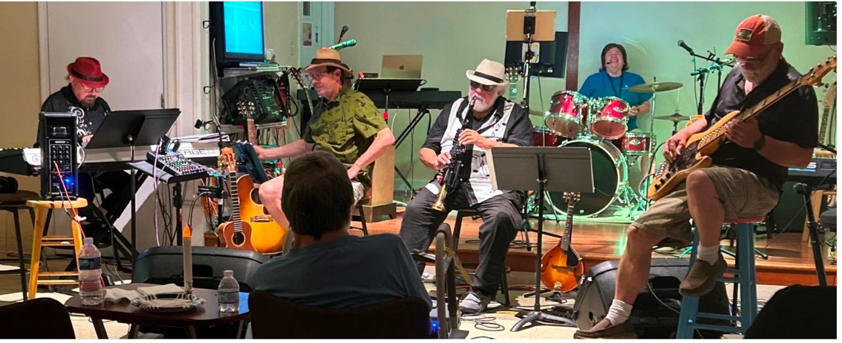

15 .Title of Ministry or Committee: Tuesday Jam
Chairperson or Primary Contact: Bill Egan

Phone Number: (757) 357-3840

Email Address: bill.egan2@gmail.com
Statement of Mission or Purpose: Our mission is to create a setting in the local community for musicians at all levels to gather weekly at Parish Hall at Christ Church to play and sing a wide range of music.

16. Title of Ministry or Committee: Special Events
Chairperson or Primary Contact: Kimberly Leazer

Phone Number: 757-810-4100

Email Address: Kimberly.leazer@yahoo.com
Statement of Mission or Purpose: Special events in which Christ Church participates may be staged by the church itself or may be among those developed by other community organizations such as: the Town Office of Tourism, Historic Smithfield, Isle of Wight County Museum,Isle of Wight Arts League, or Wharf Hill partners. These usually serve as fundraisers for community organizations while providing opportunities for visitors and local residents to enjoy the offerings of both businesses and non-profits in the Town of Smithfield.

17. Title of Ministry or Committee: Sundays at Four Performance Series
Chairperson or Primary Contact: marycole@tidewaterarts.com

Phone Number: 757-675-5777

Email Address: marycole@tidewaterarts.com
Statement of Mission or Purpose: To provide a venue where professional artists and accomplished students can perform and share their art with the public.
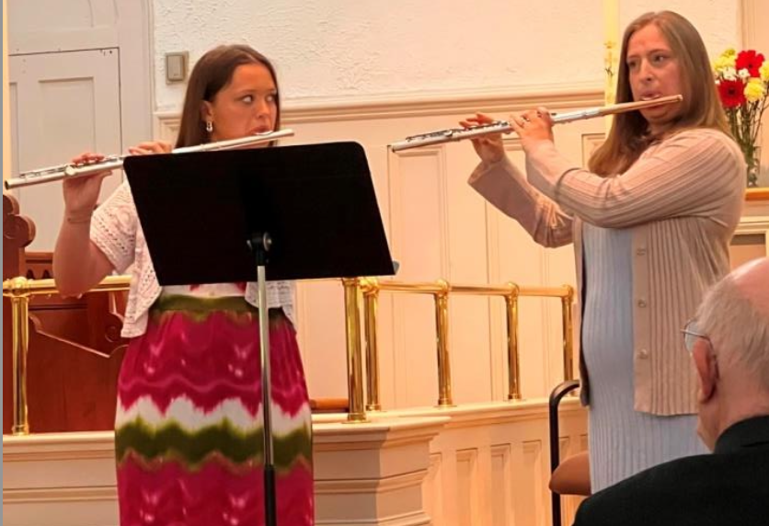

WORSHIP
18. Acolytes/Crucifers
Chairpersons or Primary Contacts: Betty Dubinsky and Tim Jones

Phone Number: 757-357-6496

Email Address: esdubi@hotmail.com

Statement of Mission or Purpose: To assist the Rector in performing services in the sanctuary of Christ Church.

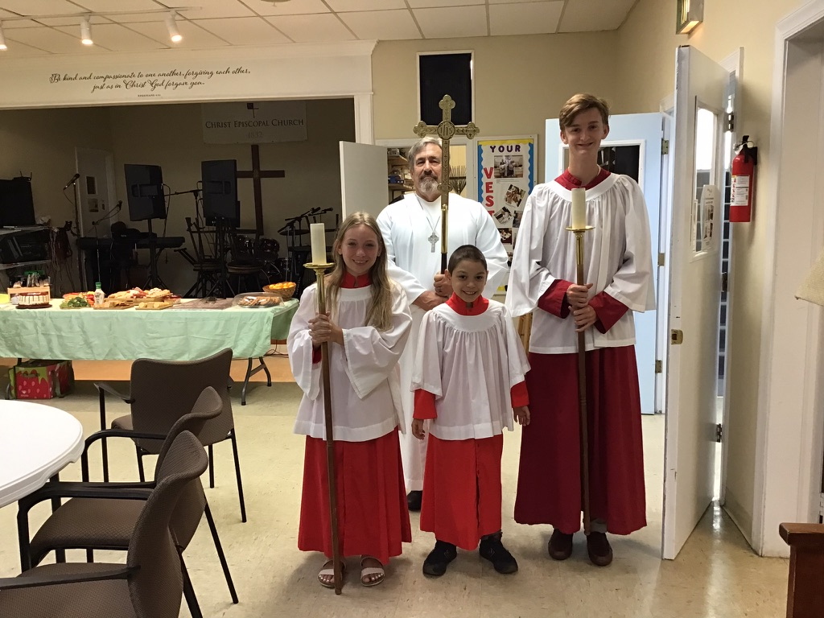

19. Altar Guild
Chairperson or Primary Contact: Judy Cutler

Phone Number: (757) 357-5133

Email Address: cutlerjudy@hotmail.com
Statement of Mission or Purpose: To respectfully and reverently care for the altar in the Christ Church sanctuary and to support the Rector in conducting services there.

20. Flower Guild
Chairperson or Primary Contact: Alison Crocker
Phone Number: 518-505-5966

Email Address: : acrocker53@gmail.com
Statement of Mission or Purpose: To provide appropriate floral arrangements for the altar. They are to be placed for each service. These may be arranged by Flower Guild members or by a florist. The Flower Guild is not responsible for weddings or funerals or for the outside of the church building.
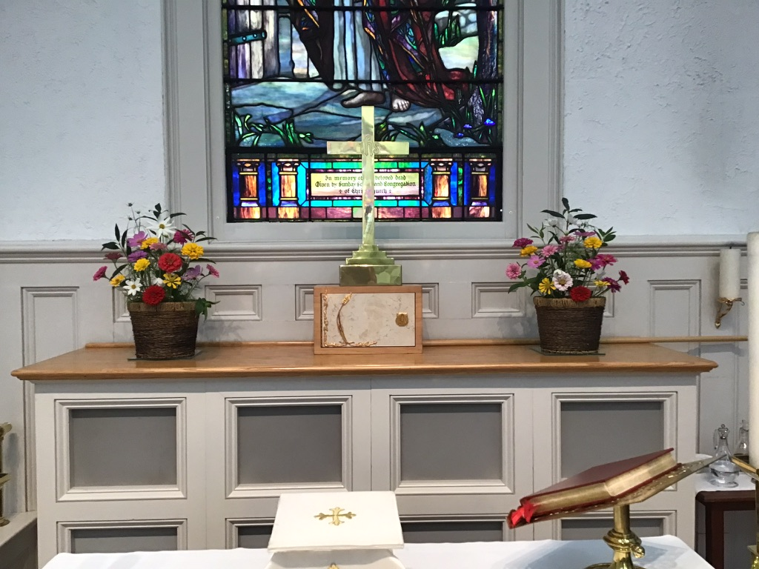

21. Lay readers/Lectors
Chairperson or Primary Contact: Beth Harris

Phone Number: (757) 357-2826

Email Address: admin@christchurchsmithfield.org

Statement of Mission or Purpose: To assist the Rector in the performance of worship services at Christ Episcopal Church.

22. Music Programs
Chairperson or Primary Contact: Mary Cole

Phone Number: 757-675-5777

Email Address: marycole@tidewaterarts.com
Statement of Mission or Purpose: To enhance the worship experience at Christ Episcopal Church through presentation of a variety of musical offerings.

23. Ushers
Chairperson or Primary Contact: Annamaria Pencola

Phone Number: (757) 407-6333

Email Address: pencolaa@yahoo.com
Statement of Mission or Purpose: To facilitate participation of Christ Church services by serving as hosts to Parishioners and Visitors in attendance.

